Activity No 1. IT Club Activity “Information Technology Quiz”
Title of the Event | IT Club Activity “Information Technology Quiz ” | 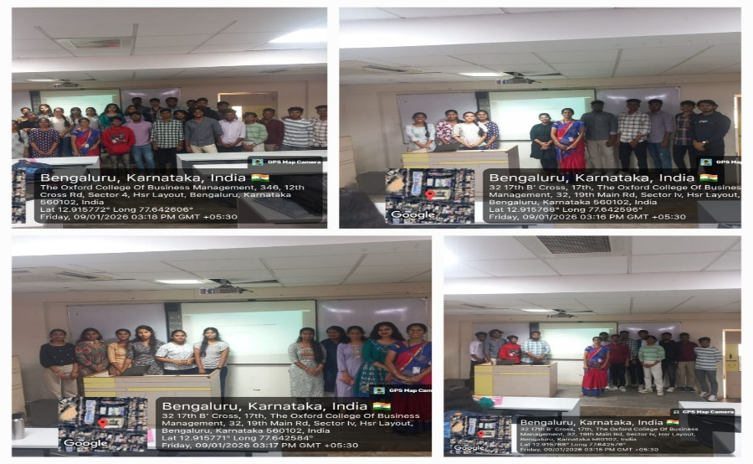
Day and Date | 09.01.2026
Venue (With all details ) | Roon No-309
In collaboration with ( if any) | -
Details of Resource Person With Designation | T.M. Kavitha | 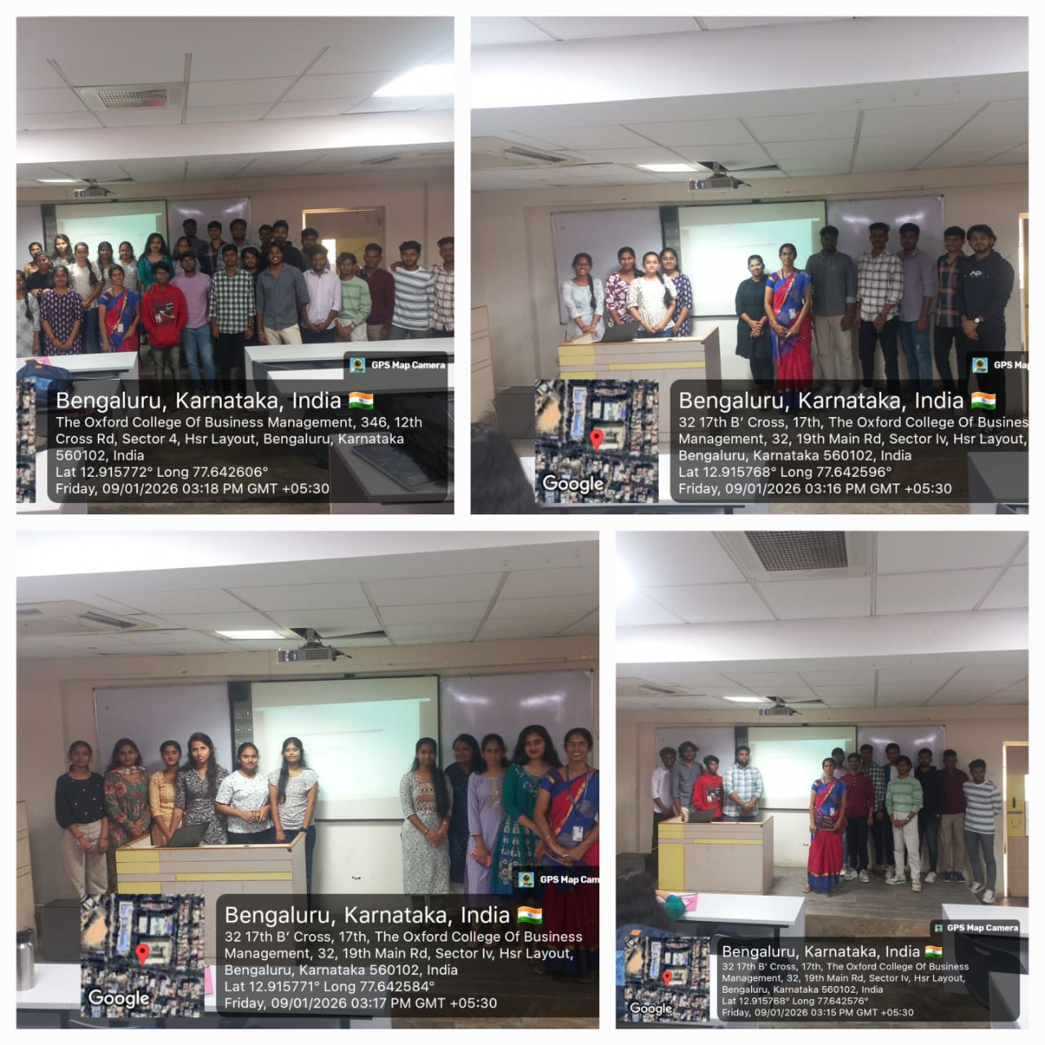
Organizing Department/Coordinators | Business Management .  T.M Kavitha
Course and semester | MBA I Semester
No of Students & Faculty Participants | 41

Coordinator HoD Vice-Principal Principal

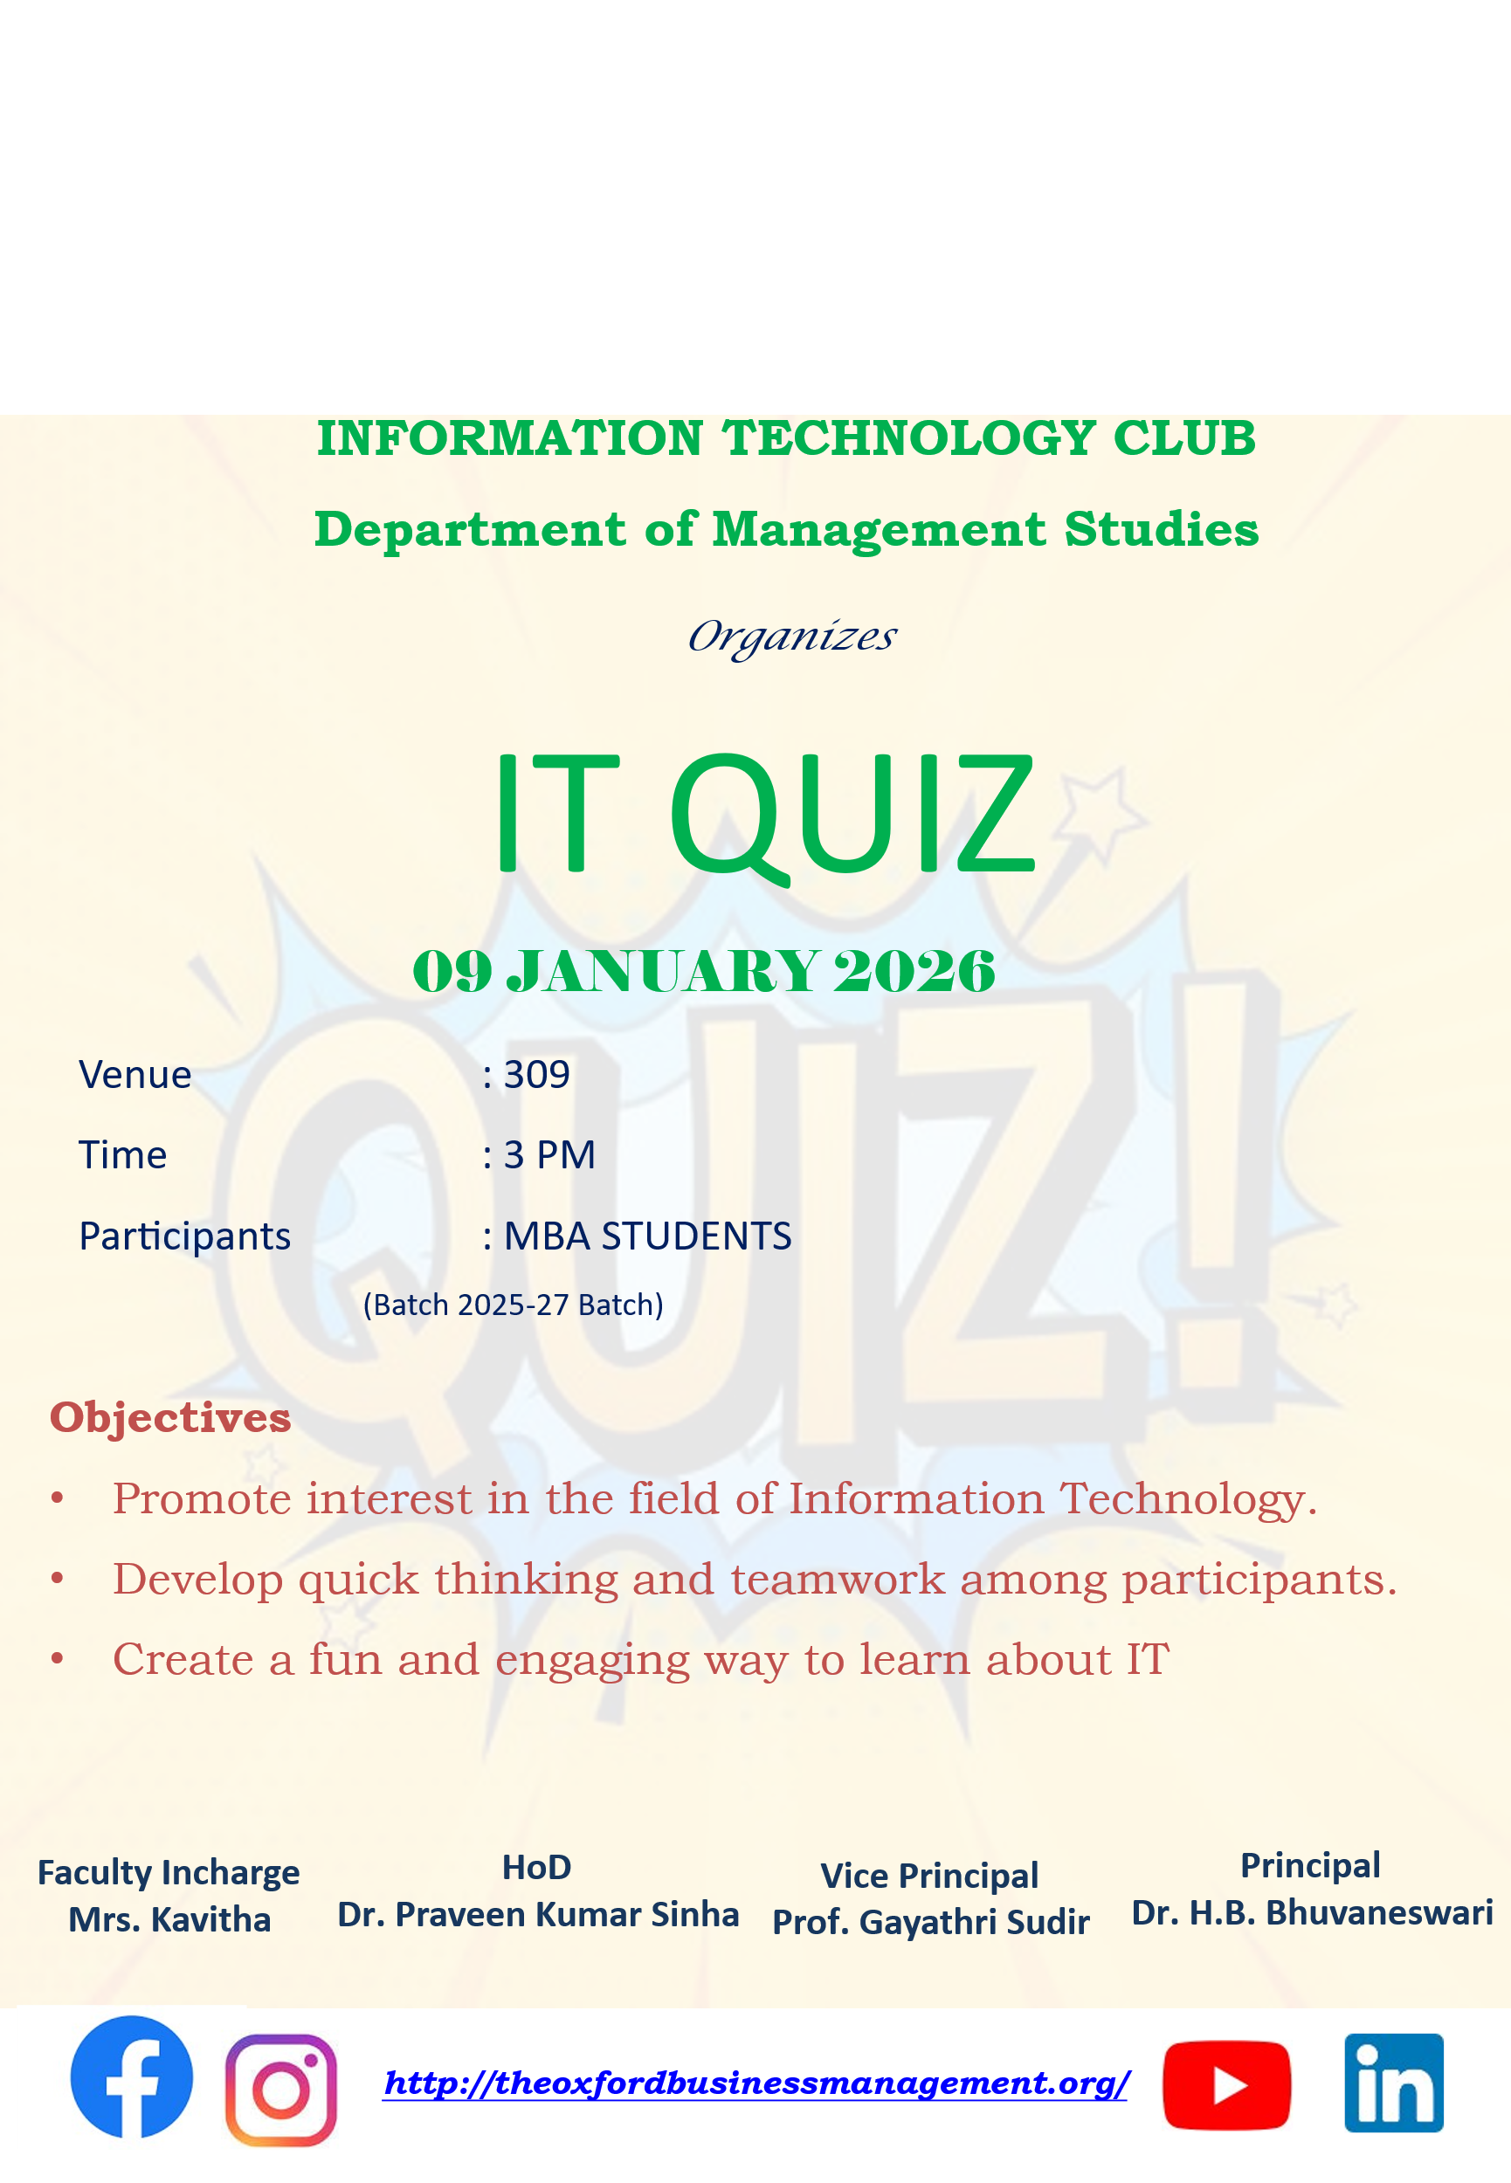
The Department of Management Studies organized an IT Quiz Competition on 09-01-2026, in the Room No: 309. The event aimed to encourage awareness of current trends in Information Technology and enhance the technical knowledge and competitive spirit among students. The primary objective of the IT Quiz was to Promote interest in the field of Information Technology. It also aims at developing quick thinking and teamwork among participants. The event also creates a fun and engaging way to learn about IT.

The preliminary round was based on General IT Knowledge in which questions were based on general informations. The second round was visual round which was based on identifying the logo and brands of leading organisations. The competition was intense and showcased the strong IT awareness among students. Audio-visual aids were used to make the quiz more interactive. Enthusiastic audience participation added to the excitement. The IT Quiz was a resounding success, achieving its goal of enriching the IT knowledge base of students and fostering a spirit of healthy competition. The Department looks forward to organizing more such events in the future to promote learning beyond the classroom.

